**The first scenario**

The system should display a welcome screen when opening the application for the first time.

The system must provide a splash screen that appears to the user when opening an application every time.

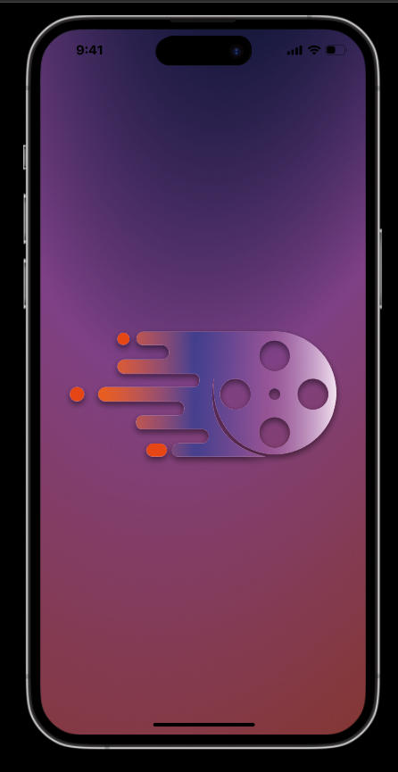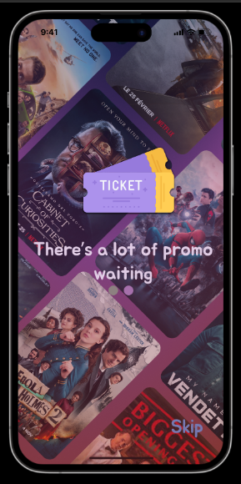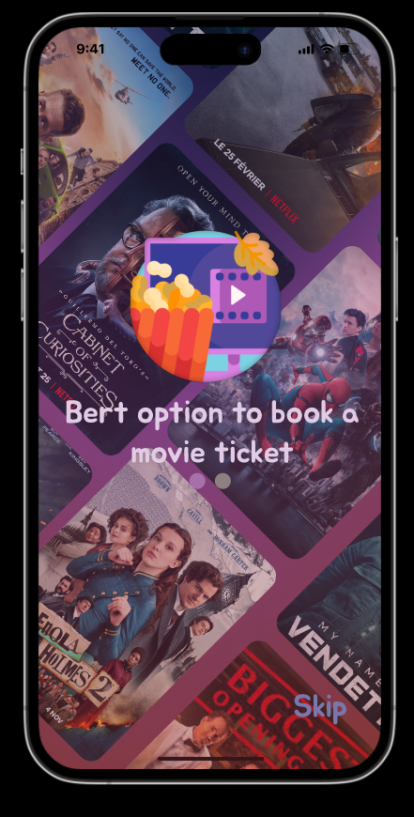

**Second scenario**

The system must provide the user with the ability to log in to the system through the email and password.

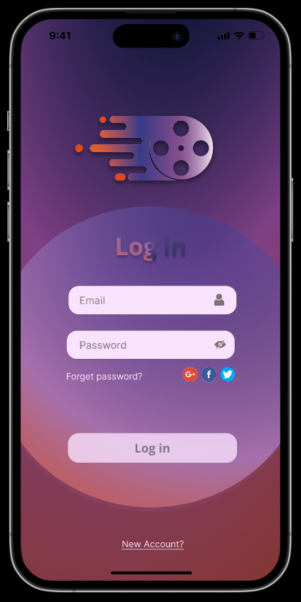

**The third scenario**

The system must provide the user with the ability to create a new account with a username, email, number, and password.

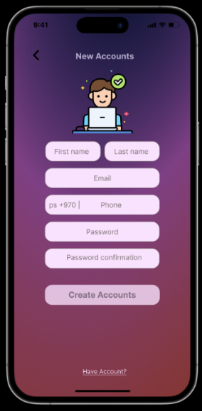

**Fourth scenario**

The system must provide the user with the ability to retrieve the account through the phone number.

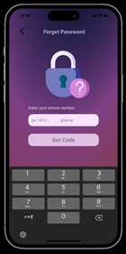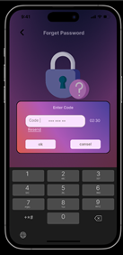

**Fifth scenario**

The system should provide the user with a home screen display containing a search, profile, navigation bar, and movies.

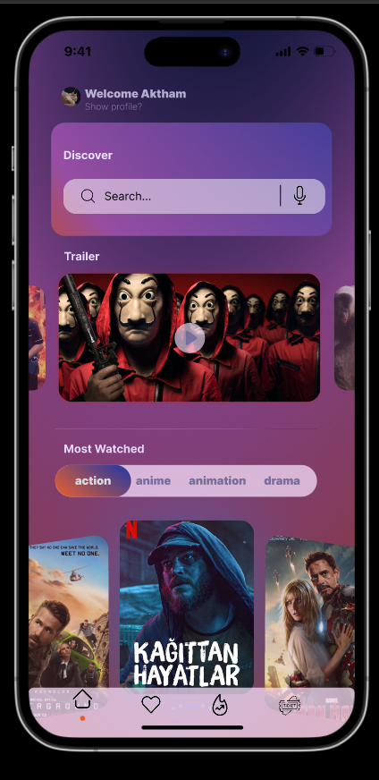

**Sixth scenario**

The system must provide the user with navigation between pages

**Seventh scenario**

The system must provide the user with the ability to view the videos that he liked.

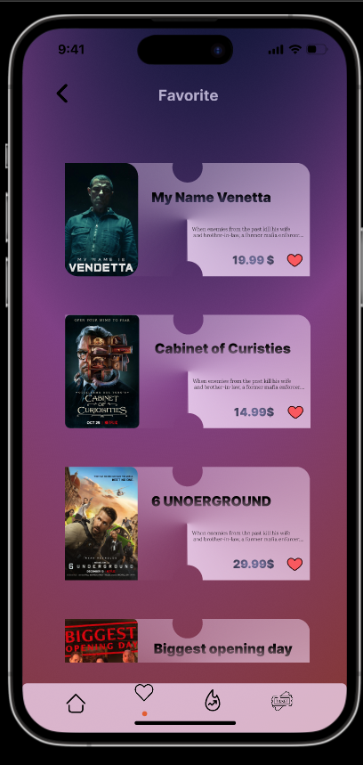

**Eighth scenario**

The system should provide the user with the ability to view and watch the most requested videos.

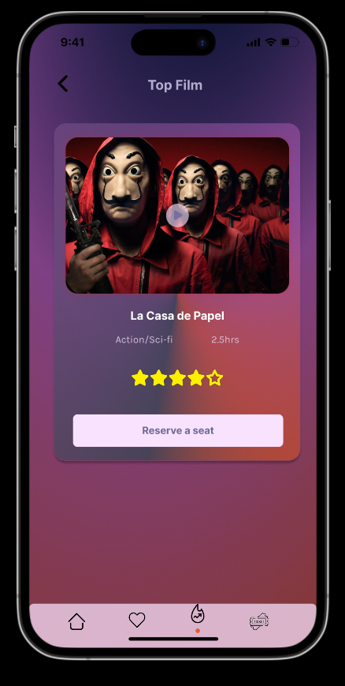

**The ninth scenario**

The system should provide the user with the ability to view his ticket.

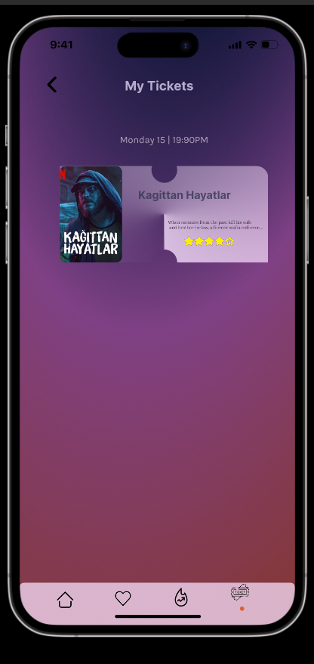

**Tenth scenario**

The system should provide the user with the ability to display the search bar.

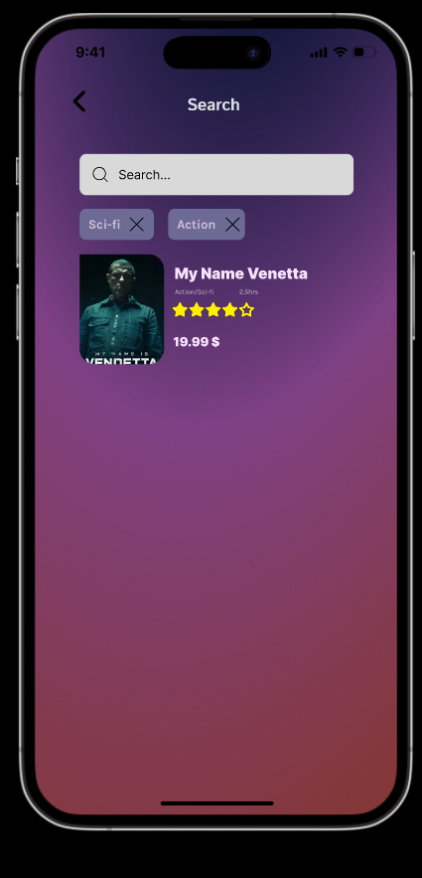

**Eleventh scenario**

The system should provide the user with the ability to have a profile through which the user can modify the data, delete the account, log out, etc.

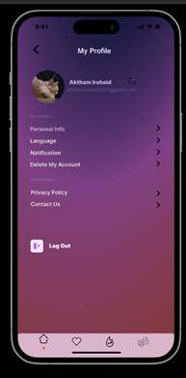

**Twelfth scenario**

The system must provide the user with the ability to modify his personal information.

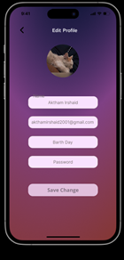

**Thirteenth scenario**

The system should provide the user with the ability to view the video and its information and the ability to book an appointment.

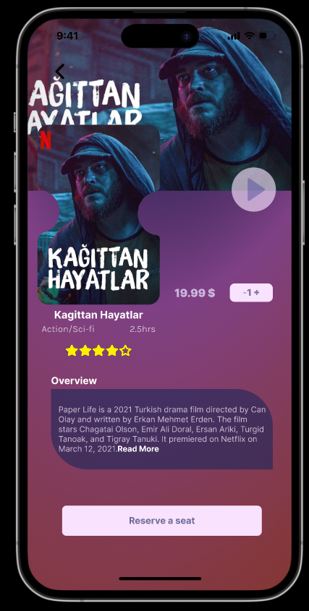

**Scenario fourteen**

The system must provide the user with the ability to book an appointment with a date and time and the ability to reserve a seat.

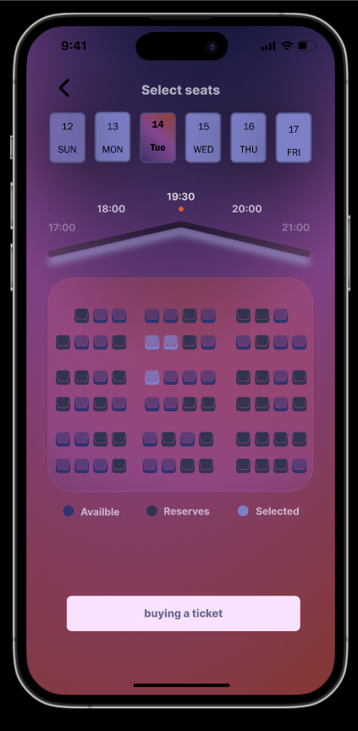

**Scenario XV**

The system should provide the user with the ability to pay Visa and verify the purchase.

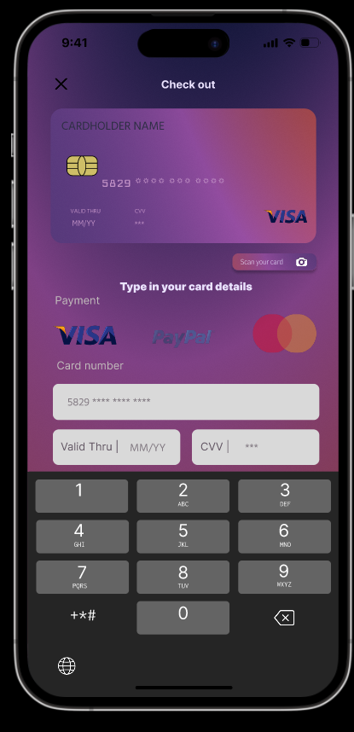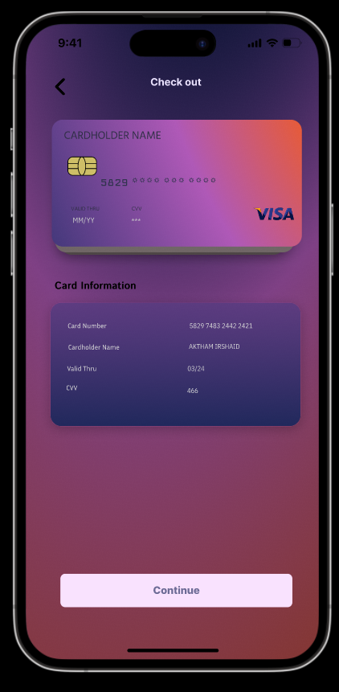

**Scenario XVI**

The system must provide the user with the ability to view the ticket that he has purchased.

